**Mini-project**

Write a **MATLAB m-code** to perform the complete fault analysis and thus find the

1. Fault current
2. During fault voltage
3. Line flows

for a 3-phase symmetrical fault.

**Submitted by,**

**Sambhav R Jain 107108103**

**Yash Kampoowale 107108095**

**Sandeep Rao 107108105**

**Initial Calculations**:

Consider an N bus power system, with a 3-phase symmetrical fault occurring at bus ‘k’

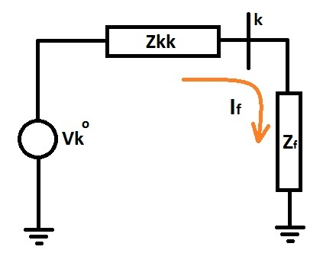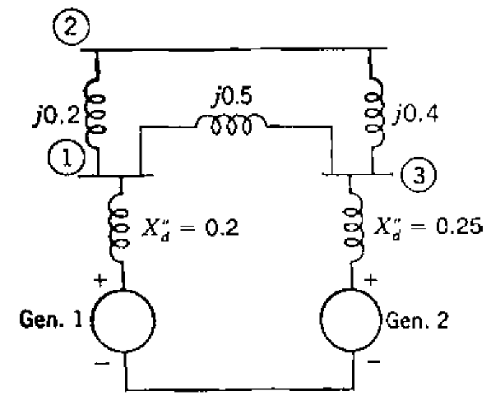

Figure 1

Figure 2

Thevenin equivalent of the system looking into it from the kth bus would be as shown in Figure 2. The fault current If at the kth bus can be found from this equation:

$$I_{f}=\frac{{V_{k}}^{0}}{Z_{kk}+Z_{f}}$$

Now, compute the difference matrix, by multiplying the Zbus matrix with the injected fault current matrix as shown by this equation:

$$\left[\begin{matrix}∆V_{1} \\ ∆V_{2} \\ ⋮ \\ ∆V_{k} \\ ⋮ \\ ∆V_{N}\end{matrix}\right]=\left[\begin{matrix}Z_{11} & Z_{12} & ⋯ & Z_{1k} & ⋯ & Z_{1N} \\ Z_{21} & Z_{22} & ⋯ & Z_{2k} & ⋯ & Z_{2N} \\ ⋮ & ⋮ & ⋱ & ⋮ & ⋱ & ⋮ \\ Z_{k1} & Z_{k2} & ⋯ & Z_{kk} & ⋯ & Z_{kN} \\ ⋮ & ⋮ & ⋱ & ⋮ & ⋱ & ⋮ \\ Z_{N1} & Z_{N2} & ⋯ & Z_{Nk} & ⋯ & Z_{NN}\end{matrix}\right]×\left[\begin{matrix}0 \\ 0 \\ ⋮ \\ -I_{f} \\ ⋮ \\ 0\end{matrix}\right]$$

Thus the during-fault voltages at the kth bus can be found as:

$${V_{k}}^{f}={V_{k}}^{0}+∆V_{k}$$

$${V_{k}}^{f}={V_{k}}^{0}-Z_{kk}I_{f}$$

Line flows:

$${I_{mn}}^{f}=\frac{{V_{m}}^{f}-{V_{n}}^{f}}{z_{mn}}$$

* *zmn* being the physical impedance connected between bus ‘m’ and ‘n’

**Flowchart**:

**M-code**:

% -----------------------------------------------------%

% Power System Simulation Laboratory -- Mini-project %

% -----------------------------------------------------%

% Sambhav R Jain 107108103 %

% Yash Prakash 107108095 %

% Sandeep Rao 107108105 %

% -----------------------------------------------------%

clc;

clear all;

close all;

fprintf('3-phase symmetrical fault analysis\n\n');

N = input('Enter the number of buses in the existing power system (excluding reference bus): ');

fprintf('\nAssume\n1. Reference bus is denoted by "0"\n2. If there is no impedance between two buses, enter NaN\n\n');

% Formulation of Zbus, by forming Ybus followed by inversion

disp('Enter the physical impedances between buses:');

for m = 1:1:N

% Case 1: Impedance between two buses

for n = m+1:1:N

% These are the physical impedances between buses, and not the Zbus

% elements

z(m,n) = input(sprintf('Enter the z(%d,%d) (e.g. 2j): ',m,n));

% Check if two buses are not at all connected (infinite impedance)

% i.e. NaN - Not a Number

if isnan(z(m,n))

% If yes, then the admittance would be zero

y(m,n) = 0;

else

y(m,n) = 1/z(m,n);

end

y(n,m)=y(m,n);

end

% Case 2: Impedance between a bus and the reference bus

z(m,m) = input(sprintf('Enter the z(%d,0) (e.g. 2j): ',m));

if isnan(z(m,m))

y(m,m) = 0;

else

y(m,m) = 1/z(m,m);

end

end

rowsum = sum(y,2);

for m = 1:1:N

for n = 1:1:N

if m == n

% Diagonal elements of Ybus (Ymm) = sum of all admittances connected

% to the mth bus

Y(m,n) = rowsum(m);

else

% Off diagonal elements of Ybus (Ymn) = negative of the admittance

% connected between m and n

Y(m,n) = -y(m,n);

end

end

end

Z = inv(Y);

fprintf('\nThe Zbus of the given power system is:\n');

disp(Z);

% Finding which buses are generator buses and which are load buses

for m = 1:1:N

g(m) = input(sprintf('\nFor bus %d:\n 1 -> Generator bus\n 2 -> Load bus\nChoose: ',m));

end

while 1

k = input(sprintf('\nEnter the bus index at which a 3-phase fault is to be simulated: '));

if k >=1 && k <= N

break

else

fprintf('\nError!! Please enter a value between 1 and %d!\n',N);

end

end

Zf = input(sprintf('\nEnter the fault impedance (zero in case of bolted fault): '));

V = ones(N,1); % Pre-fault voltages are assumed to be 1 p.u.

I = zeros(N,1);

I_f = 1/(Z(k,k)+Zf); % Fault current at bus 'k'

fprintf('\nPer-unit fault current out of bus %d:\n',k);

disp(I_f);

I(k,1) = -I_f;

del_V = Z*I; % Difference in voltage vector

Vf = V + del_V; % During-fault voltage vector at buses

fprintf('During-fault voltages (p.u.):\n');

for m = 1:1:N

fprintf('Vf_%d = ',m);

disp(Vf(m));

end

fprintf('During-fault currents (p.u.):\n');

for m = 1:1:N

for n = m+1:1:N

if isnan(z(m,n))

If(m,n) = 0;

else

If(m,n) = (Vf(m,1)-Vf(n,1))/z(m,n);

end

fprintf('If_%d%d = ',m,n);

disp(If(m,n));

end

end

% Fault current from generator terminals

for m = 1:1:N

if g(m) == 1

If(m,m) = (1-Vf(m,1))/z(m,m);

fprintf('If_g%d = ',m);

disp(If(m,m));

end

end

**Terminal Display:**

3-phase symmetrical fault analysis

Enter the number of buses in the existing power system (excluding reference bus): 3

Assume

1. Reference bus is denoted by "0"

2. If there is no impedance between two buses, enter NaN

Enter the physical impedances between buses:

Enter the z(1,2) (e.g. 2j): 0.2j

Enter the z(1,3) (e.g. 2j): 0.5j

Enter the z(1,0) (e.g. 2j): 0.2j

Enter the z(2,3) (e.g. 2j): 0.4j

Enter the z(2,0) (e.g. 2j): NaN

Enter the z(3,0) (e.g. 2j): 0.25j

The Zbus of the given power system is:

0 + 0.1447i 0 + 0.1195i 0 + 0.0692i

0 + 0.1195i 0 + 0.2465i 0 + 0.1006i

0 + 0.0692i 0 + 0.1006i 0 + 0.1635i

For bus 1:

1 -> Generator bus

2 -> Load bus

Choose: 1

For bus 2:

1 -> Generator bus

2 -> Load bus

Choose: 2

For bus 3:

1 -> Generator bus

2 -> Load bus

Choose: 1

Enter the bus index at which a 3-phase fault is to be simulated: 4

Error!! Please enter a value between 1 and 3!

Enter the bus index at which a 3-phase fault is to be simulated: 2

Enter the fault impedance (zero in case of bolted fault): 0

Per-unit fault current out of bus 2:

0 - 4.0561i

During-fault voltages (p.u.):

Vf_1 = 0.5153

Vf_2 = 0

Vf_3 = 0.5918

During-fault currents (p.u.):

If_12 = 0 - 2.5765i

If_13 = 0 + 0.1531i

If_23 = 0 + 1.4796i

If_g1 = 0 - 2.4235i

If_g3 = 0 - 1.6327i

**Results and Discussion:**

1. The equations required to perform the 3-phase symmetrical fault analysis are derived for an N-bus system, to support any generic system
2. The N-bus system is treated as an N-port network and hence its Thevenin circuit is used to obtain the fault current
3. A MATLAB code is written to simulate the fault at any specified bus, in a given power system network
4. The fault current and during fault voltages are computed, from which, the line flows are calculated and displayed
5. By repeatedly simulating the fault analysis at different buses in a network, the rating of the circuit breaker can be determined from the maximum of line current during each of these simulations